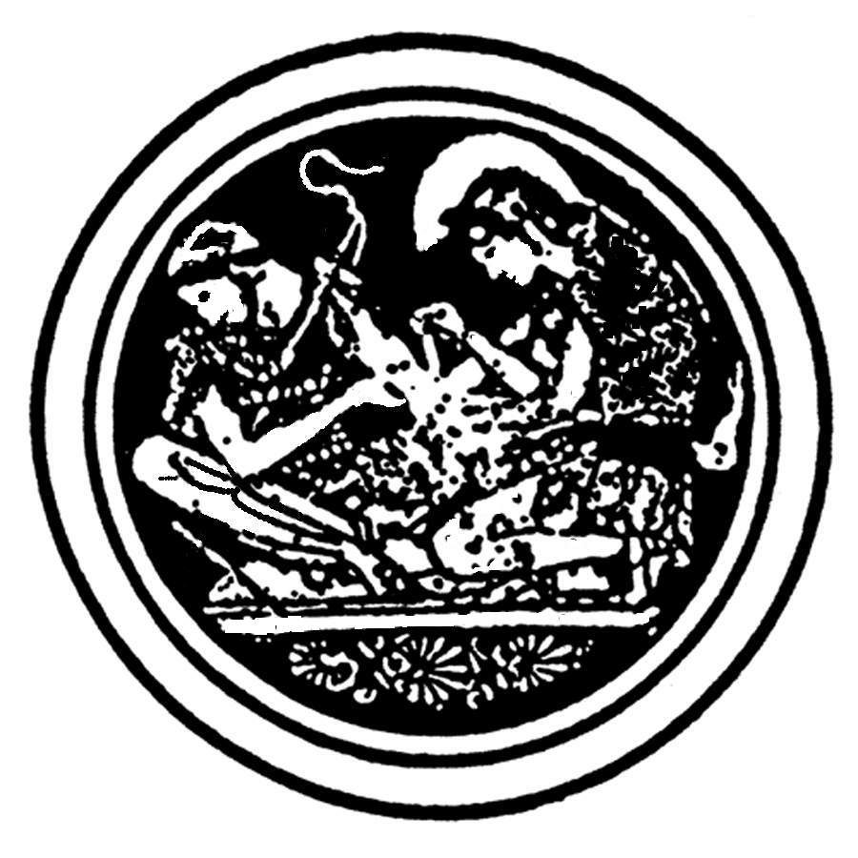

New England Hellenic Medical and Dental Society

SCHOLARSHIP APPLICATION

Eligibility Criteria:
- The Scholarship shall be designated the “New England Hellenic Medical and Dental Society (NEHMDS) Scholarship”.

- The NEHMDS will award a scholarship to a student(s) member of NEHMDS of Hellenic descent based upon academic performance and/or need. This student will in the next academic year attend an accredited medical, dental institution.

- The student shall have displayed an ongoing interest and commitment to the health field and to Hellenic issues.

- Scholarship monies will be given directly to the student.
Student MUST be present to receive scholarship on April 29, 2006 or else will forfeit the award.

- The Application shall be filed with the Scholarship Committee before March 20, 2006 to the following address:
NEHMDS

C/o Maria Pelidis MD
9 Holyoke Rd, Apt #2
Somerville MA 02144

- Scholarship decisions are made by a committee comprised of NEHMDS members. All information provided by the applicant will be kept strictly confidential and will not under any circumstances be distributed outside the committee.

New England Hellenic Medical and Dental Society

SCHOLARSHIP APPLICATION

I. Full Name ___________________________________
II. Date of Birth _________________________________
III. Mailing Address_______________________________
________________________________________________
________________________________________________
________________________________________________
________________________________________________

- Email address _________________________________

V. Are you a member of the New England Hellenic Medical and Dental Society? Circle one: YES NO

VI. Please attach Undergraduate and Graduate Transcripts.

(a) Name of Undergraduate University/College and Graduation Year __________________________________
________________________________________________

(b) Name of Medical or Dental School and Anticipated Graduation Year ___________________________________
________________________________________________

V1a. Please enclose a LETTER of RECOMMENDATION.

New England Hellenic Medical and Dental Society

SCHOLARSHIP APPLICATION
(continued)

VII. Please list leadership activities, service or honors received in college and/or graduate school (use an attached sheet if necessary): ________________________________
________________________________________________
________________________________________________
________________________________________________
________________________________________________
________________________________________________
________________________________________________
________________________________________________
________________________________________________

VIII. Please list any employment activities while in college and/or graduate school and dates of participation (use an attached sheet if necessary): _________________________
________________________________________________
________________________________________________
________________________________________________
________________________________________________
________________________________________________
________________________________________________
________________________________________________
________________________________________________
________________________________________________
________________________________________________
________________________________________________
________________________________________________

- Please provide a wallet size photo of yourself.

New England Hellenic Medical and Dental Society

SCHOLARSHIP APPLICATION
(continued)

- STATEMENT OF APPLICANT
(use an attached sheet if necessary)
Why do you consider yourself a worthy candidate for this scholarship?
What are your long-range goals in the health field?
How do you embody the Hellenic spirit?
How do you envision contributing to the society in the future?________________________________________________
________________________________________________
________________________________________________
________________________________________________
________________________________________________
________________________________________________
________________________________________________
________________________________________________
________________________________________________
________________________________________________
________________________________________________
________________________________________________
________________________________________________
________________________________________________
________________________________________________
________________________________________________
________________________________________________
________________________________________________
________________________________________________
________________________________________________
________________________________________________
________________________________________________

