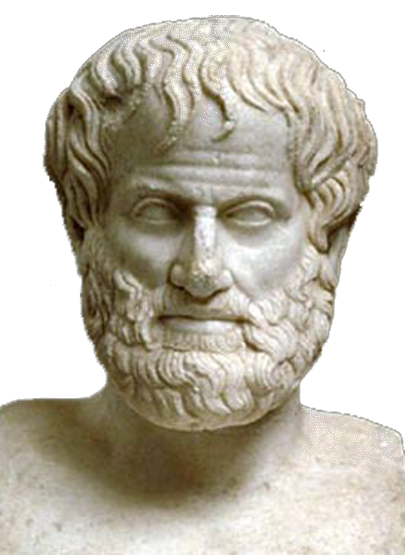 | World Congress in Philosophy (WCP 2016)  The Philosophy of Aristotle  Athens, 10-15 July 2016  School of Philosophy, National & Kapodistrian University of Athens, Greece
Template Submission Form N. 9-Society Meetings
(All fields marked with * should be completed and written in English to avoid technical problems)
1) WE HAVE SUBMITTED PARTICIPATION FORM No 1 : □ Yes
1) ORGANIZER INFORMATION (Please type in English.)
Name of Society * :
Topic for discussion (or organization meeting) *:
Title * □ Prof. □ Dr. □ Mr. □ Ms.
First (Given) Name *
Last (Family) Name *
Affiliation *
Address *
Postal Code* |  | Phone Number *
Fax Number* |  | E-mail Address *
2) PROPOSAL TITLE (Please type in English)
{Topic for discussion or organization meeting, number of meetings required by the Society etc.}

- If the number of participants is more than 3 persons, please use this Form twice or three times.
3) PARTICIPANTS LIST (Please type in English.)
Participant  1 | First (Given) Name *
Participant  1 | Last (Family) Name *
Participant  1 | Affiliation *
Participant  1 | Country *
Participant  1 | E-mail Address *
Participant  2 | First (Given) Name *
Participant  2 | Last (Family) Name *
Participant  2 | Affiliation *
Participant  2 | Country *
Participant  2 | E-mail Address *
Participant  3 | First (Given) Name *
Participant  3 | Last (Family) Name *
Participant  3 | Affiliation *
Participant  3 | Country *
Participant  3 | E-mail Address *

Date: Signature:
Please send this form as it is (i.e. not as PDF) to the following email address: secretariat@iagp.gr

