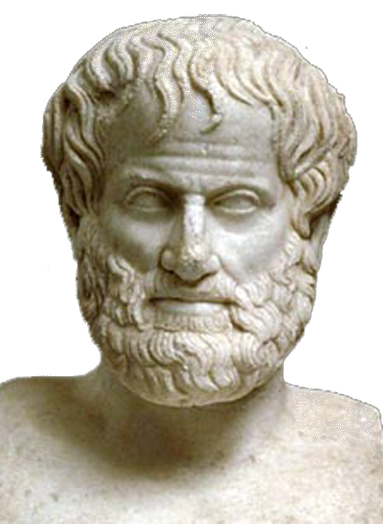 | World Congress in Philosophy (WCP 2016)  The Philosophy of Aristotle  Athens, 10-15 July 2016  School of Philosophy, National & Kapodistrian University of Athens, Greece
Template Form N. 8 for Poster Sessions
(Personal information: All fields marked with * should be completed and written in English to avoid technical problems)

* FIRST(GIVEN) NAME (Mr, Ms, Mrs,):
*MIDDLE OR OTHER NAMES:
*SURNAME (OR FAMILY NAME):
*TITLE (Prof., Dr., MPhil., MA, BA, Student):
*POSITION OR OCCUPATION:
*INSTITUTION (TEACHING OR RESEARCH):
*NATIONALITY:
*PASSPORT NUMBER:
*ADDRESS WORK:
*ADDRESS HOME:
TELEPHONE HOME & *TELEPHONE WORK:
*MOBILE:
*FAX WORK & *FAX HOME:
*EMAIL PERSONAL & *EMAIL WORK:

1. Participants in a Poster Session are kindly requested to submit their Proposal (the Topic and the description of it in total amount of words 1000-2000).

2. Each Participant is requested to send an electronic version of the text of the Proposal as an email attachment or in a CD or USB stick. Diskettes are not acceptable.

3. The maximum available space allotted for each participant of the Poster Session is: 4.40 X 3.40 cm.

4. The artistic structure of the text of the poster (letters, calligraphy, etc.) and generally its preparation is in the responsibility of the Participant.
5. Please send this form as it is (i.e. not as PDF) to the following email address: secretariat@iagp.gr

TITLE AND TEXT OF THE PROPOSAL:

Date : | Signature:

