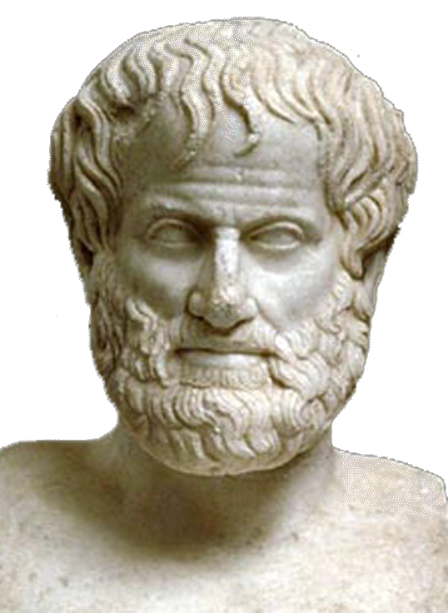
World Congress in Philosophy (WCP 2016)
The Philosophy of Aristotle
Athens, 10-15 July 2016
School of Philosophy, National & Kapodistrian University of Athens, Greece

Student Sessions
Abstract & Paper Submission Form N 6
(All fields marked with * should be completed and written in English to avoid technical problems)
1) I HAVE SUBMITTED PARTICIPATION FORM No 1: □ Yes
* Last (Family) Name:
* First (Given) Name (Mr., Mrs., Ms.):
Undergraduate: □
Graduate □ BA □ MA:
PhD Candidate: □
* Affiliation—Institution (Teaching or Research):
* E-mail Address:
2) PAPER TITLE (Please note that the duration of speaking time is 10-15 minutes. See the relevant note in the First Circular)
4) ABSTRACT (a maximum of 500 words-key-words included)
5) PAPER (please see the relevant note in the First Circular)
6) Please send this form as it is (i.e. not as PDF) to the following email address: secretariat@iagp.gr

Section:
Author(s): Papadopoulou Maria

Title of paper: Philosophy as a way of life according to Aristotle

Abstract and key-words (500 words)
………………………………………………………………………………………………………………………………………………………………………………………………………………………………………………………………………………………………………………………………………………………

Text of the paper:
…………………………………………………………………………………………………………..……….…………………………………………………………………………………………………………………...…………………………………………………………………………………………………………………...…………………………………………………………………………………………………………………...
At the end of the text, insert Author’s details and email:
[Dr. Maria Papadopoulou
Assistant Professor of Philosophy
Department of Philosophy
University of Athens
Hellas
Email:]

