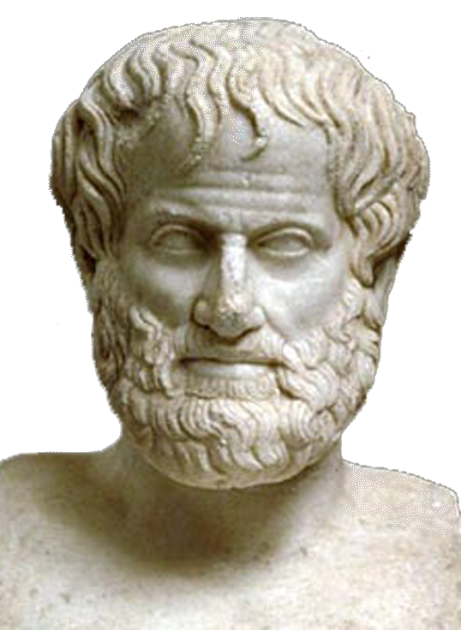 | World Congress in Philosophy (WCP 2016)  The Philosophy of Aristotle  Athens, 10-15 July 2016  School of Philosophy, National & Kapodistrian University of Athens, Greece
Template Participation Form No 2
(Only for persons to be considered as Invited Speakers)
(Personal information: All fields marked with * should be completed and written in English to avoid technical problems)

* FIRST(GIVEN) NAME (Mr, Ms, Mrs,):
*MIDDLE OR OTHER NAMES:
*SURNAME (OR FAMILY NAME):
*TITLE (Prof., Dr., MPhil., MA, BA, Student):
*POSITION OR OCCUPATION:
*INSTITUTION (TEACHING OR RESEARCH):
*NATIONALITY:
*PASSPORT NUMBER:
*ADDRESS WORK:
*ADDRESS HOME:
TELEPHONE HOME & *TELEPHONE WORK:
*MOBILE:
*FAX WORK & *FAX HOME:
*EMAIL PERSONAL & *EMAIL WORK:
I would like to participate in the World Congress on The Philosophy of Aristotle (Please Indicate with X)
AS AN INVITED SPEAKER IN A PLENARY SESSION:

1. ARISTOTLE’S ETHICS IN THE GLOBAL ERA:
2. ARISTOTLE’S THEORY OF JUSTICE AND ITS RELEVANCE IN OUR GLOBAL ERA:
3. ARISTOTELIAN CONCEPTION JUSTICE AND EUROPEAN POLITICS TODAY:
4. PLATO-ARISTOTLE AND THUCYDIDES: POLITICS AND STATE RELATIONS AS REALITY AND IDEA:
Title of the paper:
AS AN INVITED SPEAKER IN A SYMPOSIUM:
1. ARISTOTLE’S CONCEPTION OF PHILOSOPHY:
2. ARISTOTLE’S CONCEPTION OF NATURE AND THE ENVIRONMENT IN RELATION TO ECOLOGICAL ISSUES OF OUR ERA:
3. ARISTOTLE, TECHNOLOGY, SCHOLE AND THE PHILOSOPHY OF CULTURE:
4. ARISTOTLE’S CONCEPTION OF MAN AND HIS/HER ERGON:
Title of the paper :
Date : Signature:
Please send this form as it is (i.e. not as PDF) to the following email address: secretariat@iagp.gr

