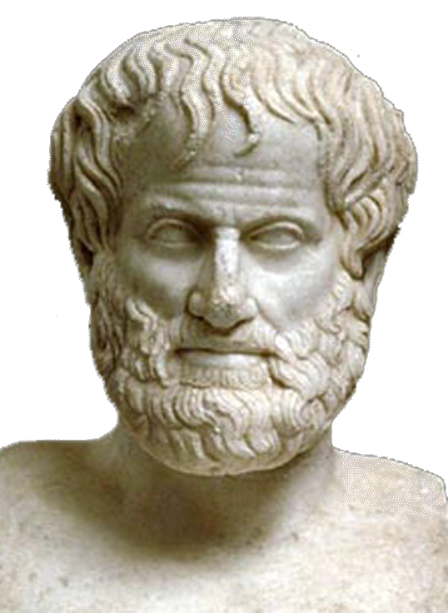 | World Congress in Philosophy (WCP 2016)  The Philosophy of Aristotle  Athens, 10-15 July 2016  School of Philosophy, National & Kapodistrian University of Athens, Greece
Template Participation Form No 11- For Press Accreditation only
(Personal information: All fields marked with * should be completed and written in English to avoid technical problems)

* FIRST(GIVEN) NAME (Mr, Ms, Mrs,):
*MIDDLE OR OTHER NAMES:
*SURNAME (OR FAMILY NAME):
*TITLE (Prof., Dr., MPhil., MA, BA, Student, etc):
*POSITION OR OCCUPATION:
*NATIONALITY:
*ADDRESS HOME:
TELEPHONE HOME :
MOBILE:
FAX HOME:
*EMAIL PERSONAL:
*EMAIL WORK:

I would like to participate in the World Congress of Philosophy on the Philosophy of Aristotle as (Please Indicate with X):

A Press Reporter representing:
Press (Newspaper, magazine)
TV
Radio
Electronic Press (website, e-magazine, blog)
Other (please specify)
Name and full contact details of the medium/media represented:
NAME:
ADDRESS:
TELEPHONE:
FAX:
CONTACT E-MAIL:
WEBSITE:
Date and signature:
Please send this form as it is.(i.e.,not as PDF) together with your updated CV to the following email address: secretariat@iagp.gr

