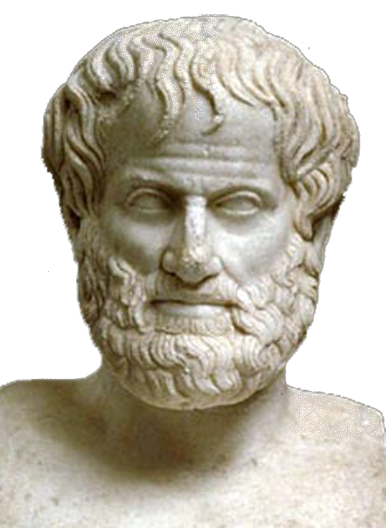 | World Congress in Philosophy (WCP 2016)  The Philosophy of Aristotle  Athens, 10-15 July 2016  School of Philosophy, National & Kapodistrian University of Athens, Greece
Template Participation Form No 10- For Volunteers only
(Personal information: All fields marked with * should be completed and written in English to avoid technical problems)

* FIRST(GIVEN) NAME (Mr, Ms, Mrs,):
*MIDDLE OR OTHER NAMES:
*SURNAME (OR FAMILY NAME):
*TITLE (Prof., Dr., MPhil., MA, BA, Student, etc):
*POSITION OR OCCUPATION:
*INSTITUTION (TEACHING OR RESEARCH):
*NATIONALITY:
*ADDRESS WORK:
*ADDRESS HOME:
TELEPHONE HOME & TELEPHONE WORK:
MOBILE:
FAX WORK & FAX HOME:
*EMAIL PERSONAL:
*EMAIL WORK:

I would like to participate in the World Congress of Philosophy on the Philosophy of Aristotle as (Please Indicate with X):

A Volunteer:
I speak fluently the following languages:
(Please Indicate with X)
GREEK
ENGLISH
FRENCH
GERMAN
SPANISH
RUSSIAN
CHINESE
Date and Signature:
Please send this form as it is (i.e. not as PDF) to the following email address: secretariat@iagp.gr

