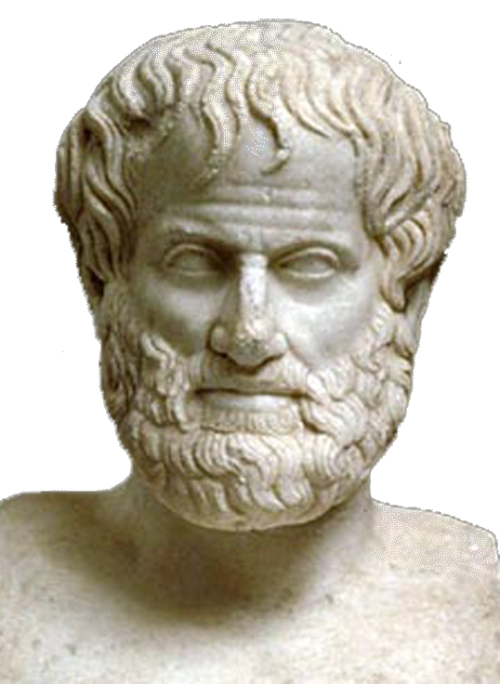 | World Congress in Philosophy (WCP 2016)  The Philosophy of Aristotle  Athens, 10-15 July 2016  School of Philosophy, National & Kapodistrian University of Athens, Greece
Template Participation Form No 1:
(Personal information: All fields marked with * should be completed and written in English to avoid technical problems)

* FIRST(GIVEN) NAME (Mr, Ms, Mrs,):
*MIDDLE OR OTHER NAMES:
*SURNAME (OR FAMILY NAME):
*TITLE (Prof., Dr., MPhil., MA, BA, Student):
*POSITION OR OCCUPATION:
*INSTITUTION (TEACHING OR RESEARCH):
*NATIONALITY:
*PASSPORT NUMBER:
*ADDRESS WORK:
*ADDRESS HOME: Bucharest ,Bd. Timişoara 27, bl.H, sc. A, ap.17, Romania
TELEPHONE HOME & *TELEPHONE WORK:
*MOBILE PHONE :
*FAX WORK & *FAX HOME:
*EMAIL PERSONAL & *EMAIL WORK:
I would like to participate in the World Congress of Philosophy on “The Philosophy of Aristotle” (please indicate with X):
As an Invited Speaker in a Plenary Session:

As an Invited Speaker in a Symposium:

AS a Speaker in one of 31 sections for contributed papers:
As a participant in a Round Table Session:
As a Participant in a Society Meeting:
As a Participant in a Poster Session:
As a Post-graduate Student with a paper:
As an Undergraduate or Post-graduate Student without a paper:
As an Accompanying person:
A person attending the Congress without a paper:
As a Volunteer (mainly Greek people):
As a Representative of Press:
Title of the paper (in relation to 31 sections):
Date : Signature:
Please send this form as it is (i.e. not as PDF) to the following email address: secretariat@iagp.gr

